



**Fayoum University**

**Faculty of Computing and Artificial Intelligence**

**Smart Parking**

**Presented by**

Abdelrhman Abouelenan Omar Ehab Ahmed Mahmoud

Mohamed Sayed Mohamed Yaaqob Mohamed Sayed Mohalhal

Abdelrhman Rabie Ashry Ahmed Mansour Abdelghani

Ahmed Khaled Mohamed

**Supervised by**

Dr: Esraa El Hariri

Dr: Asmaa Hashem

**Team Members**

|  |  |  |
| --- | --- | --- |
| **Name** | **Department** | **Email** |
| Abdelrhman Abouelenan Gaber | CS | aa5184@fayoum.edu.eg |
| Mohamed Sayed Mohamed Yaaqob | CS | ms4001@fayoum.edy.eg |
| Abdelrhman Rabie Ashry | CS | ar2243@fayoum.edu.eg |
| Ahmed Khaled Mohamed | CS | Ak1751@fayoum.edu.eg |
| Omar Ehab Ahmed Mahmoud | IS | Oe1168@fayoum.edu.eg |
| Mohamed Sayed Mohalhal | CS | ms4002@fayoum.edu.eg |
| Ahmed Mansour Abdelghani | CS | am5427@fayoum.edu.eg |

Table of Contents

Team Members.................................................................................. 2

Chapter 1 (Introduction)……………………………………………… 5

1.1 Introduction………………….………………………………………… 6

1.2 Problem Statement……………………….……………………………..7

1.3 Motivation to use Smart Parking………………………….…………… 7

1.4 Objectives ……………………………………………………………....9

1.5 Outcome…………………………………………………………….......9

1.6 Organization of the Documentation…………………………………….10

Chapter 2: (Project Planning)……………………………………….….11

2.1 Organization and Staffing…………… ……………………….……… 12

2.2 Financial Projections……………………….…………………….……..13

2.3 Schedule………………...……………………………………………....14

Chapter 3 : (Background And Related Work).........................................17

3.1Overview....................................................................................................18

3.2 Background...............................................................................................18

3.3 IoT-based smart parking system………………………….……………..19

3.4 Computer vision-based smart parking system..........................................26

3.5 Mobile application-based smart parking system.......................................27

3.6 Summary of surveyed state-of-the-art studies …………………..………28

Chapter 4 : (System Analysis and Design)...............................................34

4.1 Overview ………………………………………………………………...35

4.2 Input and output for the system ………………………………………….35

4.3 System Framework……………………………………………………….35

4.4 Analysis…………………………………………………………………..37

4.4.1 Use case diagram……………………………………………….37

4.5 Functional and non-functional requirements……………………………41

4.5.1 Functional requirements ……………………………………….41

4.5.2 Non-functional requirement (NFR)…………………………….42

4.5.3 Context diagram………………………………………………..43

4.5.4 Data flow diagram……………………………………………...44

4.5.5 Activity diagram……………………………………………….45

4.6 Design ………………………………….……………………………………….47

4.6.1 Sequence diagram ……………………………………………………...47

References ……………………………………………………………...51

Chapter 1

**Introduction**

* 1. **Introduction**

Smart car parking in Egypt aims to address the problem of limited and inefficient parking in urban areas of the country, utilizes advanced technology to optimize the use of available parking spaces, and improve the overall parking experience for drivers.

As one of the most populous countries in the world, Egypt has a rapidly growing number of registered vehicles, with over 17 million registered cars on the road. However, limited infrastructure and inadequate urban planning, this has led to severe traffic congestion and air pollution in major cities such as Cairo. Statistics show that up to 30% of traffic in urban areas is caused by drivers searching for parking spots. The same statistics indicate that this congestion results in increasing the rate of air pollution by 25%. [1]

The smart parking system will use a combination of sensors, cameras, and mobile applications to provide real-time information on available parking spots, guiding drivers to them and reducing congestion on the roads. The system will also allow for contactless payment and permit allocation, making the parking process more efficient and convenient.

Additionally, aims to reduce the carbon footprint by reducing the amount of time cars spend idling while searching for parking. By reducing traffic congestion, also aims to improve the overall air quality in urban areas. This is important because air pollution is one of the most serious environmental issues in Egypt, as it causes many health problems, such as respiratory problems and cancers.[2]

Also aims to enhance the overall parking experience for drivers by providing them with the ability to reserve parking spots in advance and providing them with real-time information on available spots. This will not only save drivers time and effort but also help to reduce the number of cars on the road in search of parking spots.

Smart parking is a crucial step toward creating more livable cities in Egypt. By reducing traffic congestion and improving the overall parking experience, the project will have a positive impact on the community and the environment. Furthermore, this project can help to reduce the amount of time and fuel wasted on searching for parking spots, and thus, it will have a positive impact on the economy.

* 1. **Problem Statement**
* Limited availability of parking spots in urban areas of Egypt results in severe traffic congestion and air pollution.
* The high number of registered vehicles combined with inadequate urban planning and limited infrastructure exacerbates the problem.
* The process of searching for and finding a parking spot can be time-consuming and frustrating for drivers.
* These problems cause several issues such as an increase in fuel consumption, air pollution, wasted time and effort, and reduced quality of life in urban areas.
* The current parking system is not efficient and does not provide real-time information about parking spot availability.
* The current payment methods for parking are not convenient and require physical contact.
* The current parking allocation system is not fair and does not guarantee equal access to parking spots.
* The need for an advanced technology system that utilizes sensors, cameras, and mobile applications to optimize the use of available parking spots, provide real-time information, enable contactless payment, and fair allocation of parking spots.
  1. **Motivation to use Smart Parking**
* Users locate the best parking location available, saving time, resources, and effort. The parking lot fills up quickly, allowing businesses and corporations to use the available space well.
* Reduced traffic - As fewer vehicles are required to look for available parking spaces, traffic flow increases.
* Pollution reduction - Locating parking consumes almost a million barrels of oil every day. The ideal parking solution will greatly reduce the amount of time spent traveling, which will reduce daily car emissions and eventually the environmental impact on the world.
* Improved User Experience - A smart parking system will combine all aspects of the user experience into a single activity. The procedure of arriving at the destination includes the driver's payment, location search, spot identification, and time alerts.
* New Revenue Streams - A lot of new revenue streams are conceivable with smart parking technologies. For instance, parking lot owners can provide tiered payment alternatives based on the location of the parking space. To attract repeat customers, reward schemes can also be included in current models.
* Integrated Payments and POS - Returning users may utilize account invoicing and application payments from their phones to replace daily laborious cash payments. Additionally, this would make useful user feedback and client loyalty programs possible.
* Greater Safety - Security officers and parking lot staff have access to real-time lot data that can be used to stop parking infractions and suspicious activities. Cameras that can read license plates can collect relevant data. Additionally, fewer people hunting for parking spots on the streets might lessen accidents brought on by the distraction of parking.
* Real-time data and trend insights: Over time, a smart parking system may provide data that reveals patterns and trends among users and parking lots. For lot owners looking to improve drivers and make modifications, these patterns may be quite helpful.
* More automation and less manual work result in lower management costs and less resource depletion.
  1. **Objectives**
* Automated smart parking system
* Time and effort savings.
* Decreased traffic jams.
* Reducing contamination of the environment.
* Lowering the price of petrol.
* Reducing the issues caused by unlawful parking.
* Generating extra financial and investment income.
* Advocating for the widespread movement toward mass transportation.
* Creating unique spaces for those with disabilities and supporting them.
  1. **Outcome**

In this system, the user gets an application to facilitate the registration and payment process and ease of communication, as well as a place equipped for the parking process, as well as protection.

* 1. **Organization of the Documentation**
* **Chapter 1: Introduction**
  + Introduces the proposed system and presents its objectives.
* **Chapter 2: Project Planning**
* Project planning details all tasks which need to be done, by whom, and when.
* **Chapter 3: Background and Related Work**
  + This chapter includes information about Competitors who have ideas that are similar to our idea.
* **Chapter 4: System Analysis and Design**
* This chapter discusses the function and nonfunction requirements, includes system analysis and design and It describes how the system works.

Chapter 2

**Project Planning**

**2.1** Organization and Staffing

Management can be used in most careers as well as your daily life. Strong planning skills, good communication, and ability to implement a project to deliver the product or service while also monitoring for risks and managing resources.

Smart Parking has an integrated team each of whom has an effective role. Positions are distributed according to each person’s ability to perform the assigned tasks.

Position 1: Team Leader - He who manages, distributes tasks, handles team members, solves internal problems, and leads the team well.

Position 2: Android Developers (back-end) - They are who are responsible for the technical side such as back-end and coding. Briefly, they are efficient on the technical side and in writing the system code.

Position 3: Embedded Developers - they are implementing the software that is programmed into devices built around a microprocessor. they write code to solve problems and implement systems that make a physical hardware device work through software.

Position 4: Database administrator - a person who designs the database and implements it. He has the authority to manage and maintain the database.

Position 5: Reporter –who reports and documents all the steps that happen in the project.

Position 6: System administrator - Responsible for a communications network to transmit data from sensors to a central server or cloud-based system. This network can include wired or wireless technologies such as Wi-Fi, cellular, or low-power wide area networks (LPWAN).

Position 7: machine learning - We used machine learning to detect the shape of the cars that are entered into our system and use it to detect the number of cars and use it in the database.

2.2 Financial Projections

The financial projections for the cost of smart Parking Requirements are highlighted in the table below.

|  |  |  |
| --- | --- | --- |
| Tool name | Purchase page | price |
| At mega 32 | Amazon | 190 |
| lampatronics | 170 |
| Ram | 150 |
| Photo-Resistor Sensor (LDR 10MM) | Amazon | 32 |
| lampatronics | 8 |
| LM35DZ Temperature Sensors (Original – High Quality) | Amazon | 35 |
| lampatronics | 60 |
| RFID Reader-Writer Kit 13.56 Mhz | Amazon | 160 |
| lampatronics | 125 |
| Servo Motor MG996R Metal Gear 180 Degree (With Accessories) | Amazon | 420 |
| lampatronics | 190 |
| Ram | 100 |
| Ultrasonic Sensor Module | Amazon | 70 |
| lampatronics | 40 |
| Ram | 35 |
| Buzzer 5V | Amazon | 40 |
| lampatronics | 6 |
| LCD16x2 Serial Interface Board Module | Amazon | 240 |
| lampatronics | 35 |
| Flame Sensor Module | Amazon | 68 |
| lampatronics | 32 |
| Ram | 32 |

Table 2.1 (Financial projections)

2.3 Schedule

Smart Parking is expected to take no more than eight months from the project. The following is a high-level schedule of some significant milestones for this initiative.

1-8-2022: Planning phase.

16-10-2022: Initiate Analysis and requirements phase.

20-11-2022: Project Design phase.

27-11-2022: Initiate project implementation.

12-6-2023: project Testing phase.

The Development Plan Using Microsoft Project :

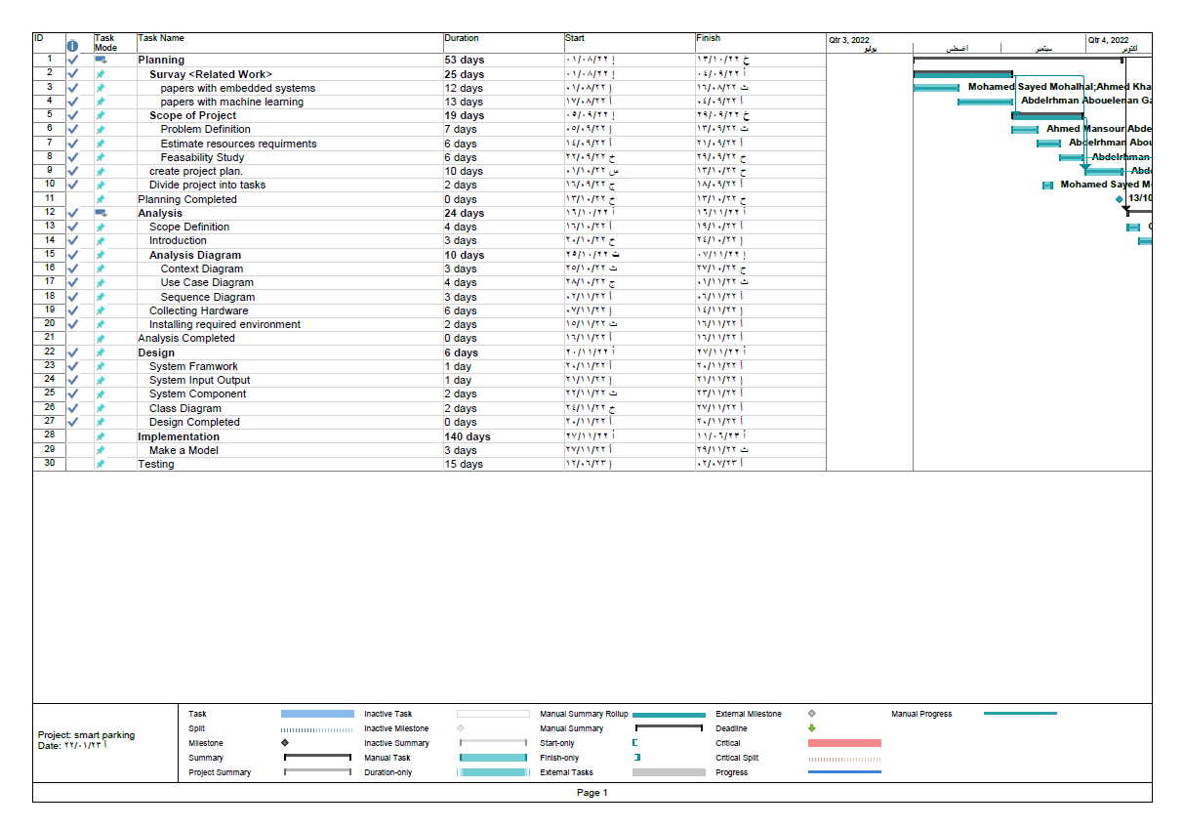

Figure 2.1

This shows the tasks of the project and the start date and end date for every task then shows the duration of every single task:

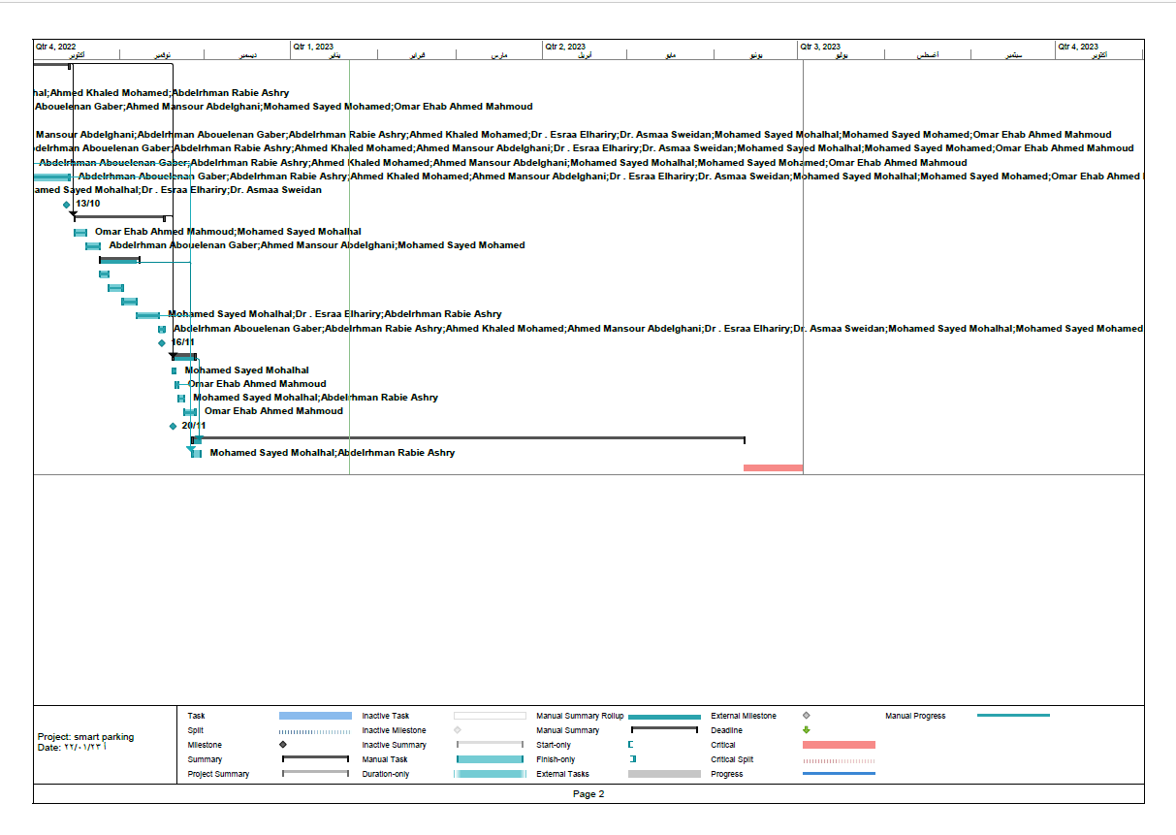

Figure 2.2

This shows the dates of official holidays during work on this project, except **for** some exceptions :

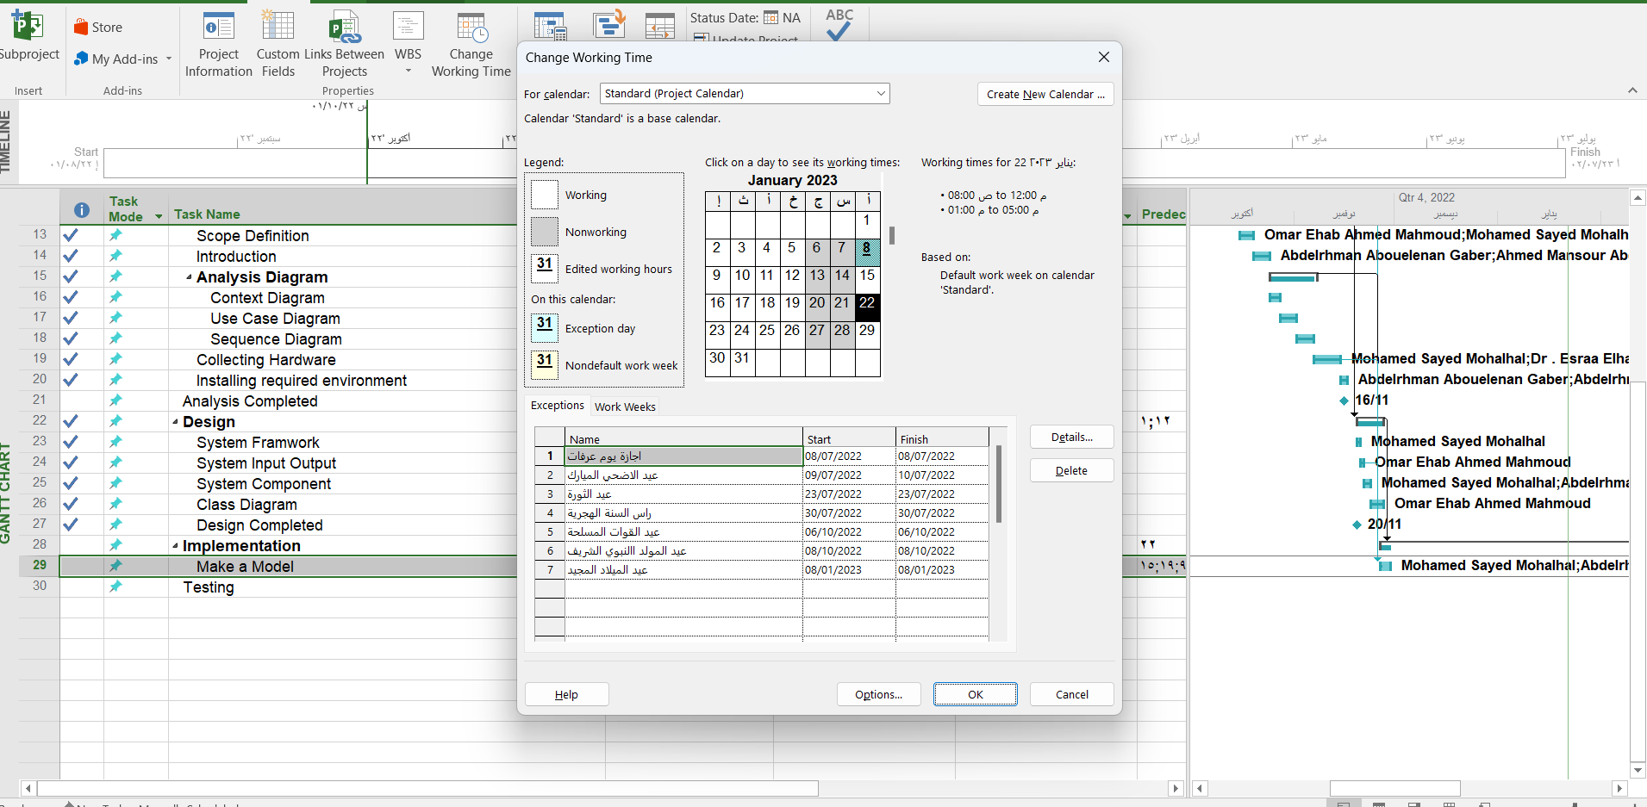

Figure 2.3

The actual progress of the project:

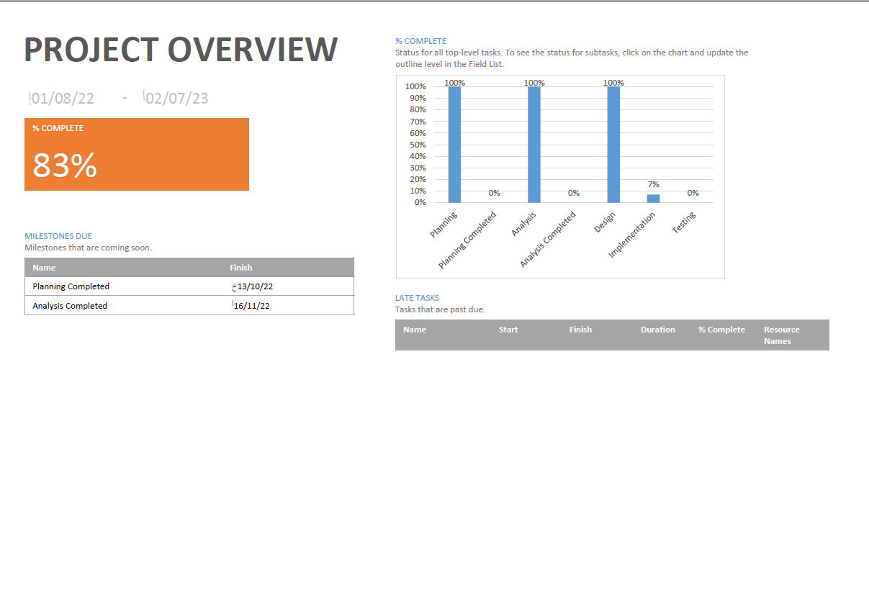

Figure 2.4

Chapter 3

**Background**

**And Related Work**

* 1. **Overview**

This chapter will discuss the literature review on how it was conducted on a smart parking system similar to the proposed project. The comprehensive review is based on the articles and information that is made available on their website. Here, the limitations of the current system are analyzed by discriminating using a side-by-side comparison of the features of the application system.

**3.2 Background**

A smart car park is an area of ​​land designated to solve some of the problems that people face while performing their daily tasks. This space is configured to meet the needs of the user or organization. In this system, many Internet of Things devices are used, which helps in raising the efficiency of the system. You find these devices at the beginning of your entry to the place, including what works to take data when the user enters, and that is in two ways. Either using the system, the car information is taken, or through the user dictates It is evidence about him such as his name, city, etc. Some of them are inside, such as sensors or LEDs, and they work to determine whether the space is empty or occupied, and some cameras monitor the place for protection. The element of space is of great importance in this system, as it is possible to create floors to make the system better. As it is known that these systems are for-profit, therefore, easy and safe methods of payment are added, which are through the mobile phone or the system for entry and exit, and non-profit, and these do not require any systems to perform payment operations, but it must be taken into account that they may need that one day.

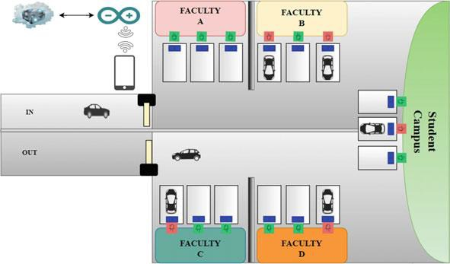

Figure 3.1 (Smart parking system)

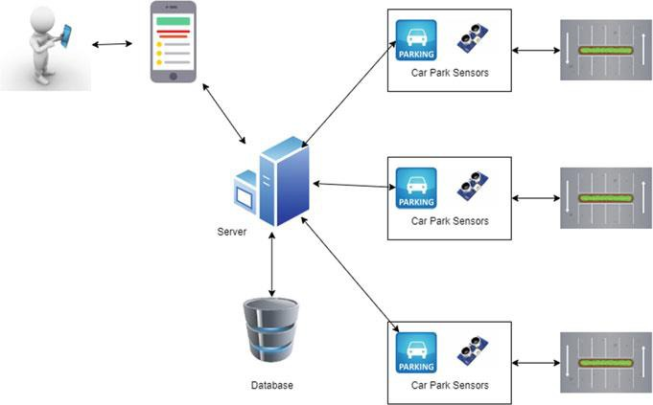 Figure 3.2 (System mobile application)

* 1. **IoT-based smart parking system**

Bojan Pradananga et al. in [3]. It is based on RFID and IOT and has used smart parking technology. The Internet of Things (IoT) is one of the key technologies in ubiquitous computing and is the primary way to create smart settings. The technology used is a very useful and unrestricted technology to improve the smart parking system using RFID (Radio Frequency Identification) technology. The goal of this project is to reduce the volume of traffic in public places where any number of issues can arise. Such as safety, parking difficulties, congestion, etc. Problems can be fixed. The use of the proposed classification, that is, data information receiving, control, and display (DMD). These elements allowed information to be shared, displayed, and improved for future use. Tools used in this project. The primary objective of this project is to create a secure car park that does not interfere with neighboring areas. By classifying the received and tracked data, it is easy to distinguish the information components of parking systems when they are displayed. This pledge relies on RFID and uses sensors and other tools to accomplish the monitoring process.

Dr. Soochang Park et al. in [4]. They proposed a smart parking system based on IoT. Now we can use Smart Parking System(D-PARK) over BLE-Beacon-based Internet of Things. Urban public spaces are progressively fitted with the Internet of Things (IoT) devices composed of ambient sensors, actuators, and beacons running Bluetooth Low Energy (BLE) that help offer continuous observability and interactivity from/to physical environments. Each beacon device constantly broadcasts its unique identifiers to nearby smart mobile devices to perform creative interactions between a mobile application and an associated cloud system for users nearby. In a car park, Global Positioning System (GPS) and WiFi signal strength-based localization are commonly employed for parking position detection of vehicles. GPS is usually used to indicate the position of a parking lot due to its large error scale and restriction in indoor environments, The accuracy of WiFi fingerprint with one access point per 100m2 is 8.5min an indoor place, this means that WiFi-based techniques cannot achieve the approximately two meter-scale.

Yasir Ali et al. in [5]. They proposed a smart parking system based on IoT. Finding parking spaces in jam-packed areas is often challenging and causes traffic congestion with a consequent wastage of time, and fuel so had designed a model to solve this problem, depending on the principles of Context and context awareness. Design a model and check it by using UPPAAL. Because it combines both fast algorithms and token techniques, reducing the complexity of complex systems validation problems, Ex(UPPAAL, MOCHA18, MCMAS 20, MCK21, SPIN 23, or 22). Kamble et al10 presented a prototype of Android centered smart parking application that assists users in reserving or pre-booking parking space using (OTP). In the work of Satre et al,31 the authors presented an RFID tag-based digital parking system. The system architecture consists of GPS, an RFID kit, Android and desktop applications, and a database. we can divide users into the parts Registered User with Planned Destination (RUPD), Registered User with Unplanned Destination (RUUD), and Unregistered User (UU).

Rekha Gupta et al. in [6] A city's reachability is sometimes evaluated by the number of vehicles, roads, and parking to accommodate it. This growth-induced motorization had resulted in parking facilities being in high demand in metropolitan areas with dense populations. The problem of the parking lots being too tiny is one that they frequently face. very same has caused issues such as mishaps, traffic jams, inappropriate demand, and environment-related risks. People frequently experience problems with parking. This proves the potential for residents' quality of life to decline. The framework uses technical components like Mobile Apps, sensors, Smart Parking Meters or Smart Parking Payment Systems, Central servers on Cloud, and Analyzing Software.

Joel Charles et al. in [7]. They created an RFID-based smart parking system with user identification. In addition, they used a Nodemcu, an RFID module, a servo motor, an LCD, an I2C module, and a 12V converter. Their primary goal was to provide payment and online operation of the smart parking system, for which Firebase is being used. A real-time database called Firebase allows users to keep their information. This can also be used to authenticate the user. In addition, it can handle IoT devices such as Nodemcu and Arduino. When the user inserts the card into the RFID module, the project is complete. The customer received from them the RFID card which can be read by the RFID module and has special value. He may attach the tag to a device that can recognize the private code, transmit the information to Nodemcu, which stores the user's data in Firebase (a database), and then retrieve the data via RFID to display the details on an LCD screen. Payment can be made if the user's card is legitimate. Also, book the site.

M. Saheer Jhugroo et al. in [8]. They proposed a smart parking system based on IoT. Searching for and getting a parking space has always been a concern on a university campus or even in smart cities and the number of vehicles moving on the road is expanding day by day, while the quantity of free spaces is still the same. An Ultrasonic sensor and ESP8266 DevKitC microcontroller are used to implement the system; which keeps all its data in the cloud. This system comprises an ultrasonic device that is employed to track and monitor whether each parking slot is vacant or not; The system proposed uses RFID technology, which is costly and each vehicle will require a unique tag. Instead, other sensors like a light-dependent resistor (LDR) or ultrasonic sensor can be used to implement the system. we can use an Ultrasonic sensor (HC-SR04) to sense the existence of a vehicle in the parking slot. The chosen sensors have good distance accuracy varying from 3 cm to 3 m. Light-emitting diodes (LED) are also connected to the microcontroller to visually display the parking status to the user. For Data Storage factors that we took into consideration and that led to the association of cloud and IoT are the size of storage, the computational ability, communicational facilities, and finally interoperability. In this system, Firebase cloud technology is used as it provides authentication services and storage facilities.

Yash Agarwal et al. in [9]. They based the Internet of Things on Wi-Fi and RFID. Mobile Applications, Infrared Sensors, RFID, and Arduino as the main components. With the help of the solution, users can easily search for nearby car parks along with the real-time availability of each car park. They can also block the required parking space through the application, followed by access to the parking lot and authentication using an RFID tag. At checkout, the amount to be paid is determined using the service usage time, determined using infrared sensor data, and the payment is processed using the linked app wallet. This technology improves overall efficiency, reliability, and comfort and reduces sources of parking spot search and pollution. They also suggested easy and enhanced security checks using RFID tags with a seamless payment e-wallet system that overcomes the queuing problem. The problem statement has been divided into two parts for ease of understanding. The first part focused on the challenges faced by customers while using existing parking lots, while the second part described the challenges faced by parking owners and establishments.

Rahman Atiqur et al. in [10]. They are based on Radio Frequency Identification (RFID) using Internet of Things (IoT) innovation. Ultrasonic sensors are set before parking spaces and a signal amplifier is used. If there is no vacant parking space, at that point the LED will blink and the parking slot completed off. When leaving the car, the RFID will look at the data and cut the exact amount, and using the IoT location, it is sent through SMS to the owner using the Global System for Mobile Communications (GSM) and GPS (Global Positioning System) progress. A mobile app is used to detect where a car is parked, and the installed units are used to talk to different vehicles. The whole system is controlled by a Raspberry Pi 4. This proposed system uses an RFID reader, ultrasonic sensors, a GSM module, a GPS module, an LED display, and a loudspeaker. The Raspberry Pi 4 is a debit card-sized single-board computer with Raspbian OS installed.

Guochao Peng et al. in [11]. They proposed surveying Westminster residents and tourists and asking them to use a smart parking service, which would yield 212 correct answers. Through a literature study, they found variables that could influence the adoption of intelligent attitude services and combined them into an explanatory model consisting of 9 items and 16 hypotheses linking them. They asked drivers who traveled a lot to London's West End to provide the data the study team used in this work. In addition to using AMOS, SPSS was used to examine the data. The plan used three technologies to collect, scan and share real-time data about parking space availability. Parking spaces are monitored with wireless sensors to determine occupancy. This information was sent to the parking management platform, which has updated the ParkRight mobile app, which may direct cars to available parking spaces. They acknowledge that this study has limitations, particularly about the survey sample, although it made contributions to theory and practice.

Nasira Muharram et al. In [12]. They are based on the Internet of Things and Mobile Applications, a location-based service. They have adopted smart parking technology by using some resources such as RFID reader, LCD 16x2, Lithium-ion battery, and Battery holder Four-wheel vehicle users can choose the best parking location by considering factors such as the number of available parking spaces, routes to travel to the target parking area, and their motivation for doing so. A smart parking system based on the Internet of Things (IoT) uses the three elements that determine the accuracy of choosing a parking lot location. The maximum number of slot capacities and the number of slot capacities available in the parking area can be found using this system. The location-based service is used to provide four-wheelers with information on the best route to reach a required parking area (LBS). Subsequently, the use of gamification technology was approved to encourage four-wheelers to adopt these two features.

K. Leela Rani et al. on [13]. They based on the Internet of Things (IoT) molding technology, used advanced sensors and controllers from Honeywell to get an organized parking system for the users. Indicates free parking spaces using LED lights, eliminating the need to search for a spot. This proposed system introduces autonomous parking spaces that regulate the number of cars that can park in a particular place at any given time based on the availability of parking spaces. When a car arrives at the entrance, it is parked at the main gate and unloaded by the driver. Using the Android application on their Android device, the user commands the Parking Controller to check the status of available parking spaces, through an SMS. Upon receipt of this command, a search for the free slot is performed and the corresponding information is provided to the user by SMS. If it is confirmed that a parking space is available, the user requests the vehicle to park in the designated space. The vehicle follows its path to the parking area entrance. Here, you are waiting and the details required to park the car in the appropriate slot are sent to the vehicle control unit. Upon receiving the information, the car will trace its route to the free parking spot. Upon successful shutdown, the data on the LCD screen is updated automatically. Support for specific networking functions is required in IoT systems rather than the standard unified network of common systems. WIFI Direct Low Energy Wireless Radio Protocols.

Raden S.B.Cokro et al. in [14]. They discussed how to solve the problems related to parking fees in Jakarta, and suggested the use of IoT technologies and system big data as a contribution to the Jakarta Smart City initiative. The use of the Internet of Things has led to the collaboration of tools and technologies that can provide control and monitoring functions for smart parking systems. Big data technology has allowed the DKI Jakarta government to easily predict the potential revenue for each parking lot across the city. The purpose of the Internet of Things is to develop technology by connecting smart things via the Internet with sensors, actuators, Bluetooth, RFID, etc., which can interact with the surrounding environment and create interactive environments. Use Hadoop MR for batch processing or Spark for stream processing to perform big data analytics. They propose an algorithm that will help motorists search and find free parking spaces in the nearest parking lots based on the distance from the driver's location. The system works on the cloud, and the databases are Apache Hadoop and Apache HBase. SPARK used light sensors to detect vehicles, and parking location data is transmitted to subsystems using a radio frequency (RF) system.

Vivekananda et al. in [15]. They proposed a system to solve the problem of finding parking spaces in congested downtown areas and metropolitans. The suggested smart parking system is composed of five components (Blockchain, RSU, Driver, Parking Owner, and TA ). This model's innovative smart parking system, which emphasizes safe information sharing while utilizing a trustworthy and equitable parking method, is included.

Aamir Anwar and others. in [16]. They discussed how 5G mobile networks can be used to build smart cities and how the parking system can be upgraded with the introduction of 5G technology. They have studied how to introduce a framework that includes safe parking, finding suitable parking for different sizes of vehicles, echolocation and location, real-time voice interaction, and touch-based interaction. 5G technology is driving the Internet of Things because it offers much faster speeds than any other mobile network. 5G is 100 times faster than 4G mobile technology. Fast response time, increased performance, reliability, scalability, and real-time. In this study, they implemented a web-based application that helps pre-book parking spaces and pay online at any time. This system consisted of four main components, real-time parking reservation via a mobile application, secure payment method for parking, availability, and reservation of parking spaces according to vehicle size, and vehicle security mechanism.

Fatima Jameel et al. in [17].An intelligent parking system based on UML, automata and VDM SL was introduced. To implement the requirements and model the system, the Unified Modeling Language was used. To view the behavior of electronic payment systems, machine theory was used. The functionality of the system includes various payment methods for indoor and outdoor parking. The model was developed using the Vienna Development Method - Specification Language (VDM-SL). The model will be analyzed using the VDM SL toolbox. The proposed Park Easy Mobile application framework focused on mobile phone usage and sensor tracking strategies using a camera that was used as a sensor to visualize parking lot occupancy. This demonstrated how the smart automated payment system will simplify the use of Jakarta's public transportation system. The suggested payment method is to use the smartphone app by scanning a QR code or with a smart card. A method is proposed to solve the problem of allocating parking spaces for connected vehicles (PAPs) over a given period. It also displayed model characteristics that were validated using the official language of TLA+ to mitigate various parking problems on the road. It will introduce a street parking system (PLC) based on wireless sensor networks (WSN). To better recognize a parked vehicle, a parking algorithm was proposed, which was based on a cycle tracking state machine. To find an ideal parking lot, the autonomy of the camper and the use of the genetic method is spatially efficient.

* 1. **Computer vision-based smart parking system**

G. Manjula et al. in [18]. They proposed a smart parking system based on computer vision, which automatically identifies empty parking spaces, so that the car can be parked even in the most comfortable places, via video image processing and neural network technologies, which develop parking management software that determines the presence of parking areas. To automatically locate parking spaces, a computer vision image recognition model was trained using video data to train the Mask R-CNN structure. A pre-processed area-based convolutional neural network (Mask R-CNN) is used to mainly label the parking spot on the source images of the entire parking lot. And implemented a smart application that, if a parking space is available, can also send information to the consumer.

M.Venkata et al. in [19]. They discussed how to recognize a vehicle's license plate by using image processing and also provide automatic door opening and closing when a vehicle is detected at a parking lot entrance. they used mobile applications to provide information on available parking spaces, and car parks security features such as fire and gas leak alarms. They used Raspberry Pi which is the control unit to control and process the operation of the entire system. They also used Liquid crystal display (LCD) monitors that are located at the entrance of the car park to show current car park availability. there are Infrared (IR) proximity sensors that are used to identify the presence of vehicles at parking lot entrances. From the captured image, the characters on the license plate can be recognized, and then the Raspberry Pi sends a signal to the servo motor to open the gate at specified intervals. The user then parks the vehicle in an available parking space. If the user wants to leave the location and move the vehicle, the date and time information is captured, which is further used to process the invoice. Physical devices are equipped with multiple sensors designed to collect data.

Md Ashifuddin Mondal et al. in [20]. This paper proposed an intelligent parking management system based on several criteria, to allow drivers/vehicle owners to select and reserve the most suitable parking space from anywhere. The system also takes into account the concept of a dynamic pricing strategy to calculate parking fees to generate more revenue from public authorities and private investors. The system used sensors to calculate the concentration index, and the average arrival time of vehicles in the parking lot, for better management and planning of the situation. Simulation results show that the proposed system will reduce the average extra driving effort required by users to find parking spaces, thus reducing congestion which in turn will reduce air pollution caused by unnecessary driving to find suitable parking spaces. This paper proposes an intelligent parking management system, based on the MCPR algorithm for scarce park resource allocation. The system was implemented to simulate performance. The proposed SPMS will help users find and reserve the most convenient parking spaces while reducing congestion, excessive fuel consumption, and pollution. The proposed system will not only help drivers find suitable parking but also help the park owner to be part of the scheme.

* 1. **Mobile application-based smart parking system**

Awad Alharbi et al. in [21]. They have defined the concept of an intelligent system based on Automatic Vehicle Number Plate Recognition by offering a web-based system to support it that allows drivers to book in advance from anywhere at any time before reaching the target car park. According to some of their data, they found that 37% of drivers during peak hours in city centers spend more than 10 minutes looking for parking spaces. In addition, 34% admitted to using parking spaces illegally, putting themselves at risk of fines and exacerbating traffic problems. Read license plates, convert license plates into black and white images, crop license plate images, process images through filtering, detect registration numbers, MATLAB interfaces for testing, and rely on the cloud and fuzzy integration in a smart city to manage distributed parking, among others. Features are all used in this paper.

[H Canli](https://scholar.google.com.eg/citations?user=GNsT-lQAAAAJ&hl=ar&oi=sra) et al. in [22]. A new Smart Parking mobile app has been developed which is learning-intensive and cloud-based. Within the application, a service based on deep learning with long short-term memory (LSTMs) has been developed to predict parking spaces. Dynamic access was provided to the LSTM model, previously generated by the user's mobile device, and the process of displaying parking occupancy at the desired location was carried out on the mobile unit by entering the relevant parameters. Energy and time savings have been achieved in this way. Accurate results were achieved with real-time parking data collected in Istanbul, Turkey. To prove the effectiveness of the proposed model, it was compared with the Support Vector Machine, Random Forest, and Arima methods. The results confirmed the promised high accuracy and reliability.

* 1. Summary of surveyed state-of-the-art studies for Smart Parking System:

|  |  |  |  |
| --- | --- | --- | --- |
| PDF number | Objectives | Methodology | result |
| 3 | The purpose of this project is to reduce the crowd level in the public places | IoT: RFID only | the frequency of traffic jams is abruptly reduced |
| 4 | 1-makes finding parking space easy with the presence of smart devices | Used mobile applications and cloud | Intelligent parking scheme with high accuracy Proximity estimation.  It has also been implemented to provide intelligent intention-based services to users in parking lots. |
| 5 | This paper aims to present a smart parking system based on the Internet of things (IoT). | IoT: Camera sensor  Used mobile application and GPS | Proposed a context-aware parking system prototype to help drivers dynamically find a real-time parking space. |
| 6 | non-polluting, autonomous vehicles for reducing traffic and noise pollution along with impactful ecological parking which ensures quick, safe parking with minimal energy consumption. | Used IoT and Cloud | Solve problems like accidents, traffic congestion, disproportionate demand, and environmental hazards |
| 7 | 1-Establishing an independent system to direct the driver to a free parking space in the vicinity  2-detects the parking space availability status | IoT: ESP8266.WiFi,  Adapter  I2C module  RFID modules RC522  Regulator IC 7805  Used mobile application and firebase | • produce small system  • produce costless system.  • More portable.  • Less complexity while using and setup. |
| 8 | makes finding parking space easy with the presence of smart devices | IoT: Ultrasonic sensors (HC-SR04)  ESP8266 microcontroller  the Wi-Fi module  LED  Used mobile applications and cloud | intelligent parking system that allocates the user a closer parking space His college |
| 9 | 1) To develop an application booking parking spots.  2) To design a system that is connected to onsite sensors to detect the available parking spaces | IoT: EM 18 RFID Reader Module  Arduino Nano  ESP-01 Wi-Fi Module    Used mobile application | The booking process using the Android app.    Notifying the user about parking in real-time. |
| 10 | 1- To develop an application booking parking spots.    2-To design a system that is connected to onsite deploy sensors | Used IOT: Raspberry pi 4,  ultrasonic sensors,  LED display,  RFID module,  Speaker,  GSM module as well as parking  Servo motor. | * Optimized parking * Saving time * Reduced traffic |
| 11 | Reducing the use of spent fuel resulting from delays in congestion | Used Ads | invested a large percentage of her income on a scheme designed to improve car parking, |
| 12 | To create a system by using the Internet of Things (IoT). That can be accessed through an Android-based application used to provide information about the maximum number of slots | IoT: RFID reader RFID tag  Jumper cable LCD 16x2 Lithium-ion battery and Battery holder.  Used mobile application.  Used Firebase, Wireshark, and Google Maps applications. | A variety of RFID reader detection distances were obtained, due to the use of the antenna on the RFID tag, which affects the operating distance |
| 13 | To design and implement a system that can help the user to search for an available parking lot | IoT: Arduino Uno  Ultrasonic sensor  Node MCU ESP8266 | Reduced pollution  Decrease driving time,  Increased Safety  Reduce accidents |
| 14 | 1-handles the creation of data through various IoT sources  2-make communication between sensors  3- Use the results of the analyzed data to produce reports. | Used IoT, big data, mobile applications, and cloud | make decisions based on real-time  Current parking decision scenarios, facilitated  Citizens and governments |
| 15 | 1 - To design and implement a system that can help the user to search for an available parking lot  2 - To protect the privacy of users | Used Mobile application: blockchain | * Emphasis on secure information exchange * Parking methodology is developed using vector-based encryption |
| 16 | 1-Insurance, car insurance, and progress insurance  Parking slots.  2- A suitable place for parking cars and cars of different sizes  3- Environmentally friendly | IOT: LCD  Keypad  Security code save  Used mobile application and 5G | Park the car in a suitable space.  Reduce latency, lower operating and energy costs, and  Bandwidth.  reduce carbon dioxide, reduce heat generation |
| 17 | 1-developing an effective solution that helps in solving the problem of conventional parking systems.  2- solution for the payment of car parks | - | the system's validation and verification, type check, and integrity check. |
| 18 | To design a system that can help to automatically identify the empty parking spaces | IoT: raspberry pi 4 with camera  Used: web and machine learning | This framework contains a graphical user interface (GUI). The proposed system shows the list of pages of the user interface |
| 19 | • Reducing the problems of parking in illegal places;  • Providing additional economic and investment income;  • Supporting the general trend towards mass transit;  • Providing special places for people with special needs and supporting them. | IoT: raspberry pi 4  camera module  IR sensor  buzzer  SD card  servo motor  LCD  fire sensor  gas sensor  used mobile application | * saving a lot of time and adding value to the environment * reducing human-generated traffic |
| 20 | 1-calculating parking charge  2- the goal of this is Smart cities, smart parking, traffic congestion, IoT, sensors, dynamic pricing | - | Guides the users to find the most suitable parking area keeping in view to minimize traffic congestion, excess fuel consumption, and air pollution.  proposed system reduces the average extra driving required by the users to find a parking area |
| 21 | • Saving time and effort;  • Reducing traffic congestion;  • Reducing environmental pollution;  • Reducing fuel consumption costs. | used web designing | • System can be used in public parking or private parking.  • Is easy to implement.  • Avoids the physical search for parking |
| 22 | make parking space occupancy prediction. | Used machine learning and mobile and deep learning. | 1-They reduced the waiting time  in the queue  2-they provided real-time parking navigation, smart theft protection |

Chapter 4

**System Analysis and Design**

4.1 Overview

In this chapter, we discuss the framework that is in this we explain what we did in the embedded system in our project**.** The analysis phase that gives drew our idea that we use a data flow diagram, context diagram, activity diagram, and use case diagram to show the inputs and outputs in the project, show the different processes, and show the entities.And discuss the functional and non-functional requirements. We discuss the Design phase which gives drew our idea that used a sequence diagram to show the inputs and outputs in the project, show the different processes and show the actors and black boxes.

4.2 Input and output for the system

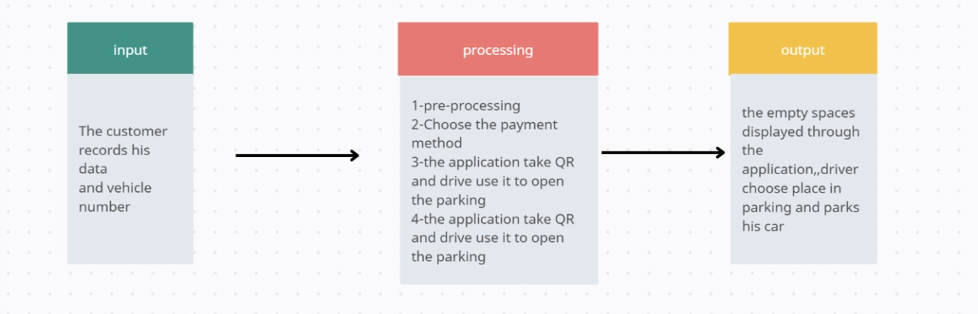

Figure 4.1 (Input and output for smart parking system)

4.3 System Framework

First, the customer enters the application, to reserve a place for him inside our smart parking, and then the payment method available to him is chosen, and then after that the system, the system will read the car’s plate. Next, the crop process would be executed to the remaining characters and numbers, then any noise-like lines would be removed. Then a template’s objects would undergo comparison to find those which are quite similar to each other to complete the identification process to find the car’s plate number and match the same in the parking database time, location, and duration). After payment, the status of the selected parking will be changed. When the driver arrives at the location by using the available map in the system, the electronic gate will automatically check the eligibility for entry to the car park depending on the picture of the car, by detecting the vehicle’s number plate and checking the database for the booking.

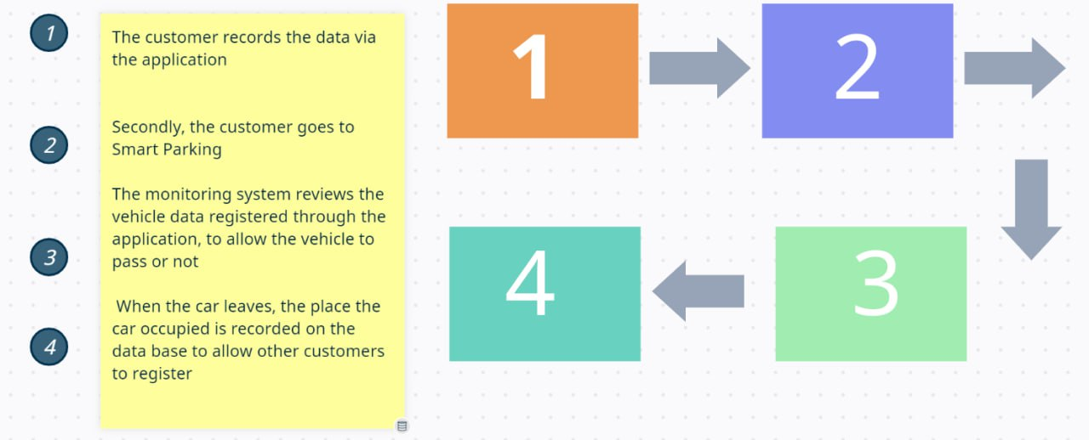

Figure 4.2 (Framework for smart parking system)

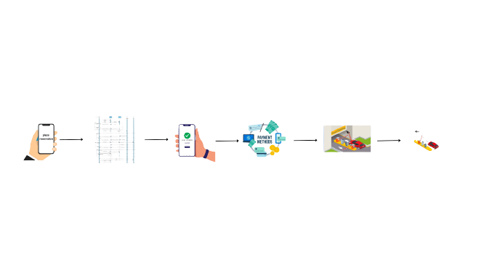

Figure 4.3 (Framework animation for smart parking system)

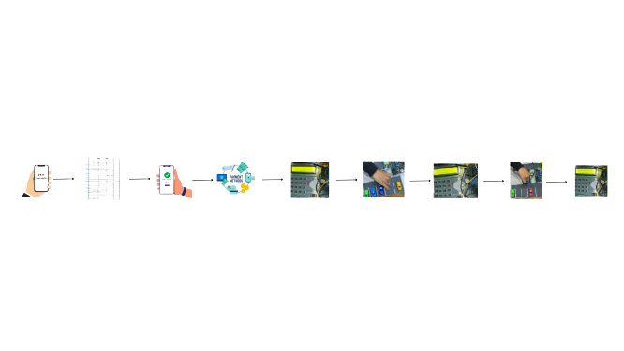

Figure 4.4 (Framework animation for smart parking system)

4.4 Analysis

In these states, we explain the use case diagram, context diagram, and DFD diagrams of non-functional and functional requirements.

4.4.1 Use case diagram:

Use case analysis is a technique used to identify the requirements of a system (normally associated with software/process design) and the information used to both define processes used and classes (which are a collection of actors and processes) which will be used both in the use case diagram and the overall use case in the development or redesign of a software system or program. The use case analysis is the foundation upon which the system will be built.

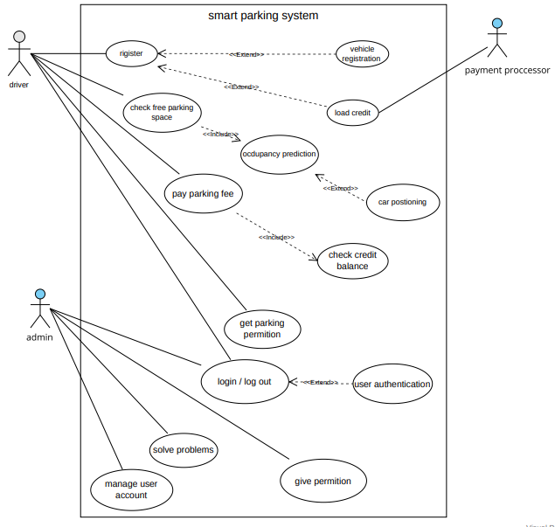

Figure 4.5 (use case diagram for parking system)

* + - 1. Table registering use case scenario:

|  |  |
| --- | --- |
| Use Case Name: | registering |
| Actor(s): | Driver or (user) |
| Description: | In this state, the user enters information about him and his car to enter the system and records it in the system |
| Actors action: | Step1: inter his name, his email, his new password  Step2: enter the information about his car like the number of this car |
| System responds: | Step3: save information in the database  Step4: send the confirmation message to the user |
| Precondition | The driver wants to park his car in the garage and wants free space for that |
| Postcondition | Users have permission to access the application and have options like loading their credit show to him information about parking |

Table 4.1

4.4.1.2 Table loading use case scenario:

|  |  |
| --- | --- |
| Use Case Name: | Loading card |
| Actor(s): | Driver or (user) and Payment Processor |
| Description: | In this state, that driver inter his card into the system and check if it is valid or not this is to take the number of  Parks turns |
| Actors action: | Step1: the driver loads his card into the system  Step3: The payment Processor checks whether er card is valid or no |
| System responds: | Step2: take the driver’s card information |
| Precondition: | The driver a valid card |
| Postcondition: | The system allows them to drive for paying parking fees and take several turns |

Table 4.2

4.4.1.3 Table occupancy prediction use case scenario:

|  |  |
| --- | --- |
| Use Case Name: | Occupancy prediction |
| Actor(s): | Driver or (user) |
| Description: | in this state, the system predicts the free spaces in the park and makes drive parks in any space he wants |
| Actors action: | Step1: driver wants free space and enters the system to get it  Step3: choose his places to park the car |
| System responds: | Step2: return all places that are free to give the driver choice |
| Precondition: | Driver pays parking fee and has several parking turns |
| Postcondition: | Take permission to park his car |

Table 4.3

4.4.1.4 Table permission use case scenario:

|  |  |
| --- | --- |
| Use Case Name: | Permission |
| Actor(s): | Admin, Driver |
| Description: | The admin gives the driver permission this permission is a QR code to park his car |
| Actors action: | Step1: driver asks to have permission  Step3: have a QR code to open the park and parks his car |
| System responds: | Step2: system send to admin that someone wants to have permission |
| Precondition: | The driver chooses his position to park |
| Postcondition: | Parks the car in the parking |

Table 4.1

4.4.1.5 Table solve problems use case scenario:

|  |  |
| --- | --- |
| Use Case Name: | Solve problems |
| Actor(s): | admin |
| Description: | If that is a problem have in system admin solve it |
| Actors action: | Step1: admin search for problems |
| System responds: | Step2: open all things to admin |
| Precondition: | Problem occurs |
| Postcondition: | Problem solved |

Table 4.5

4.5  **Functional and non-functional requirements**

* + 1. Functional requirements

4.5.1.1 For the driver:

* can enter the system and logout
* can park his car
* load his credit card
* take permission like (QR) code
* solve his problem in the system

4.5.1.2 For admin:

* can permit driver
* solve problems for the driver
* he is the manager of this system

4.5.1.3 For payment processor:

* search if that card is valid or no
  + 1. Non-functional requirement (NFR):
       1. Accuracy: the system should provide accurate results. The machine learning model must have at least 90% Accuracy and IoT must test for all machines over time.

4.5.2.2 Security: the system should be able to protect the data and resources this is achieved by:

* protect the credit card
* protect the emails
* use a QR code to enter the system

4.5.2.3 Usability: the system is easy to use, This is achieved by :

* Use a friendly GUI.
* Make the user guide the user-friendly way.
* Real-time System: the system should provide solutions at a suitable time.
* Use any available card in the system

4.5.2.4 Availability: the system should be in a specified and committable state at the start of a mission. this was achieved by:

The database can be accessed easily and quickly at any time by the admin.

4.5.2.5 Accessibility: the system should be easy to access this is achieved by:

The application will have a mobile-based version that enables to use of the system easily.

4.5.2.6 Portability defines how a system or its element can be launched in one environment or another. It usually includes hardware, software, or other usage platform specification. Put simply, it establishes how well actions performed via one platform are run on another. Also, it prescribes how well system elements may be accessed and may interact from two different environments.

* + 1. **Context** diagram:

It is primarily used to help organizations in comprehending the extent of a system. They can then determine the best way to build a new system and its specifications or how to enhance an existing system.

Context diagrams are high-level diagrams that don't depict the system's intricate workings in great detail. Instead, they provide a concise, understandable, and transparent blueprint of the entire system.

Arrows, for instance, are used to depict the data flow between the system and each external component.

Everyone can comprehend how the system functions, regardless of their level of technical expertise or technological aversion.

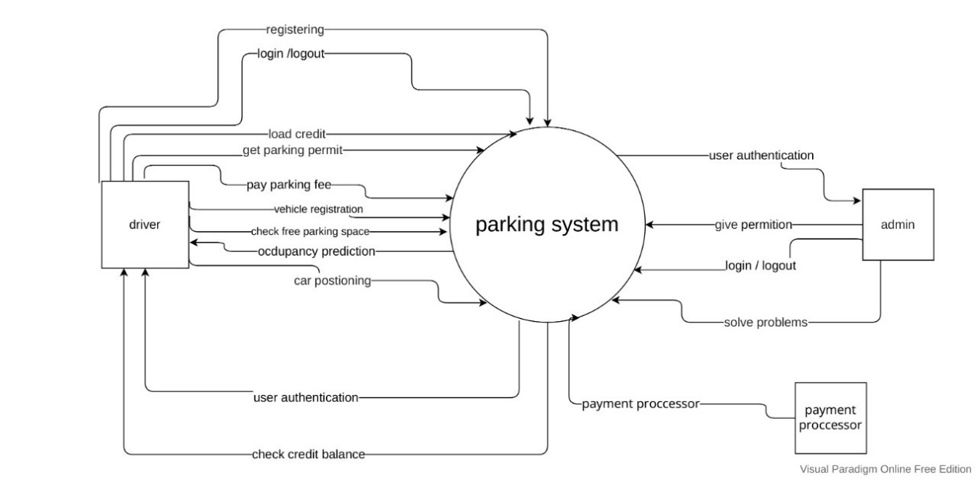

Figure 4.6 (Context diagram for parking system)

Product: parking system

External entity: driver

* Inputs
* Occupancy prediction: the system shows parking plan and free spaces to the driver
* User authentication: the system permit the user to park his car
* Check credit balance: the system check in there is enough money in the credit
* Outputs

1. Registering: the user enters his information
2. Login/logout: the user enters his e-mail and password to enter the application
3. Load credit: the user enters his credit numbers into the system to check it
4. Get a parking permit: the user enters his chosen free space to park his car
5. Pay parking fee: the user pays for the system according to his time to park
6. Vehicle registration: the user enters car information into the system to give the car authentication
7. Check free parking space: before giving user authentication the system checks if there are free spaces

4.5.4 Data flow diagram:

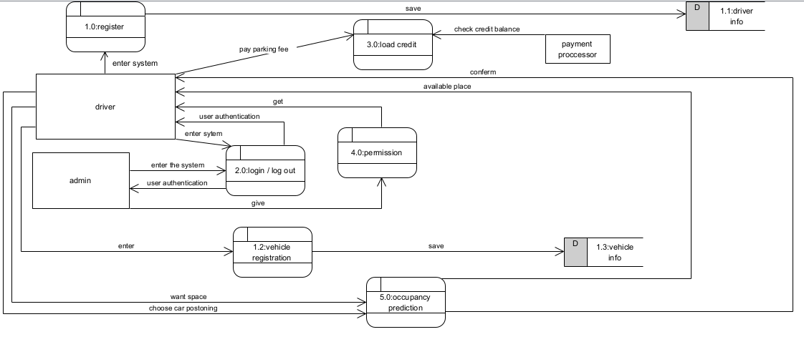

Figure 4.7 (Data flow diagram for parking system)

4.5.5 Activity diagram:

Activity diagrams show how multiple levels of abstraction of activities are coordinated to produce a service. Typically, an event must be accomplished by some operations, especially when the operation is meant to accomplish several different things that call for coordination. Another common requirement is how the events in a single use case relate to one another, especially in use cases where activities may overlap and require coordination. It can also be used to illustrate how a set of related use cases interact together to reflect business workflows.

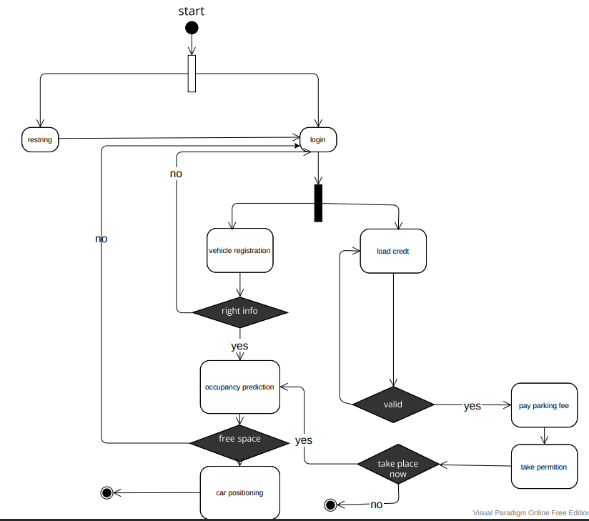

Figure 4.8 (Activity diagram for parking system)

In the beginning, the user has two options:

the first one: if the user does not have an e-mail in our application, he can make register and then login

the second one: if the user has an e-mail in our application, he can log in directly.

After login

the user can make a vehicle registration by entering car information

then the system will check:

if the car info is right:

* if there are no free spaces the system will return to the login page.
* if the car info is right: the system will make an occupancy prediction by showing the user the Garage plan and check
  + if there are free spaces: the user can Determine the car position and go to park.
  + if there are no free spaces the system will return to the login page.

if the car info is not right the system will return to the login page

* or enter his credit numbers into the system to make processes on it to take money from his Bank account

and the system will check:

* if the credit numbers are invalid, the system will show an error and return the user to load credit
* if the credit number is valid, the system will take the parking fee according to the Parking time in the garage and then take permission to park the car

and check for free space

**4.6 Design**

In this state, we explain the sequence diagram and show systems, actors, and processes.

* + 1. **Sequence** diagram:

shows [process](https://en.wikipedia.org/wiki/Process_(computing)) interactions arranged in time sequence in the field of [software engineering](https://en.wikipedia.org/wiki/Software_engineering). It depicts the processes involved and the sequence of messages exchanged between the processes needed to carry out the functionality. Sequence diagrams are typically associated with use case realizations in the [4+1 architectural view model](https://en.wikipedia.org/wiki/4%2B1_architectural_view_model) of the system under development. Sequence diagrams are sometimes called event diagrams or event scenarios.

For a particular scenario of a [use case](https://en.wikipedia.org/wiki/Use_case), the diagrams show the events that external actors generate, their order, and possible inter-system events. All [systems](https://en.wikipedia.org/wiki/Software_system) are treated as a [black box](https://en.wikipedia.org/wiki/Black_box); the diagram emphasizes events that cross the system boundary from actors to systems. A system sequence diagram should be done for the main success scenario of the [use case](https://en.wikipedia.org/wiki/Use_case), and frequent or complex alternative scenarios in this sequence diagram the black box are the parking system and database and there we have 3 actors in the use case diagram driver, admin and payment processor.

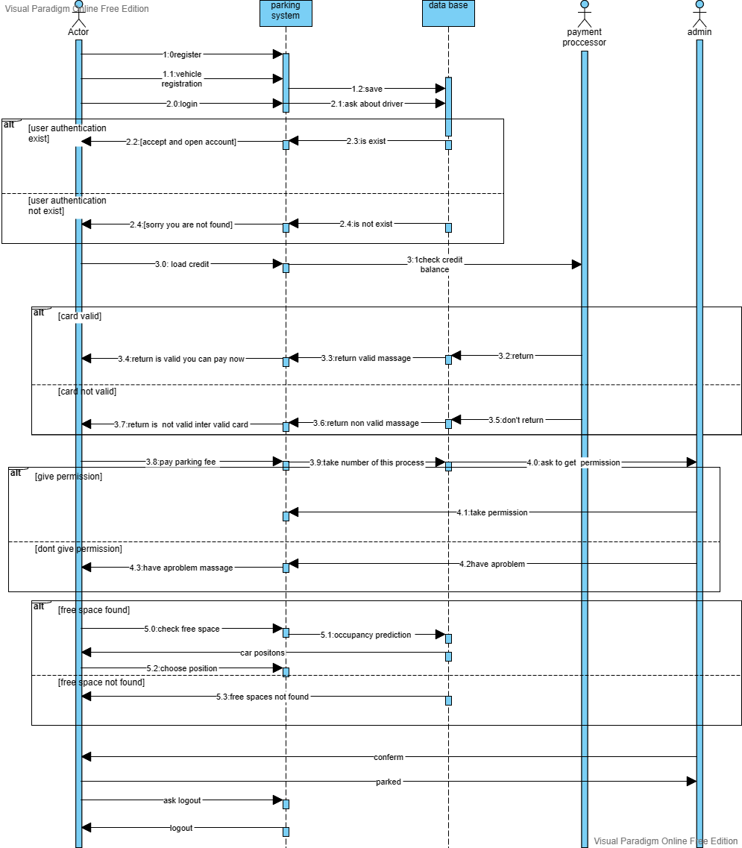

Figure 4.9 (Sequence diagram for parking system)

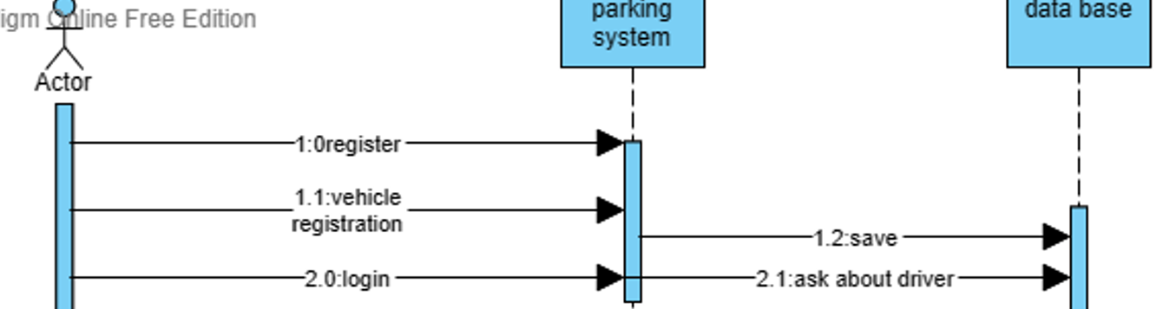

In this case, there were the actor is the driver and he has available to register and log in.

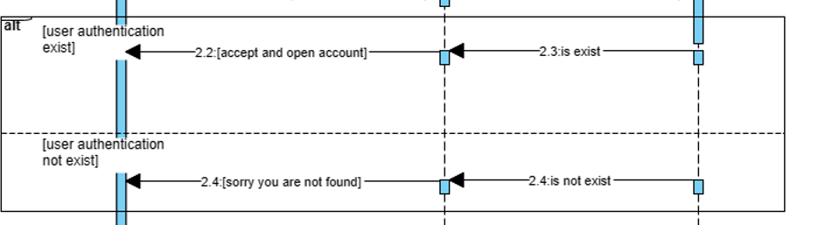

In this case that has a condition if the information is correct, enter the system. And if it is not correct don’t enter the system and ask to register in the system.

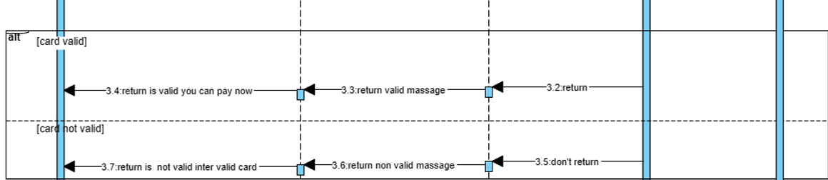

In this state condition if the card is available to get it in the database and there make driver allow to give money to the system but if it is an invalid return to the driver that invalid card and enter a valid card.

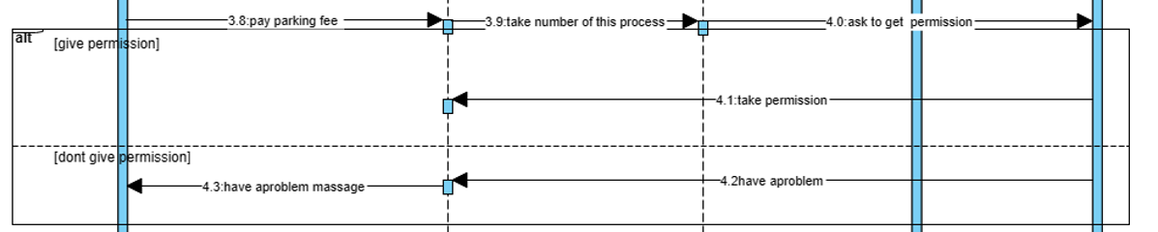

In this case, this admin permits the driver to enter the system by QR code and if have permission have it and enter to park if not have a QR Code don’t enter

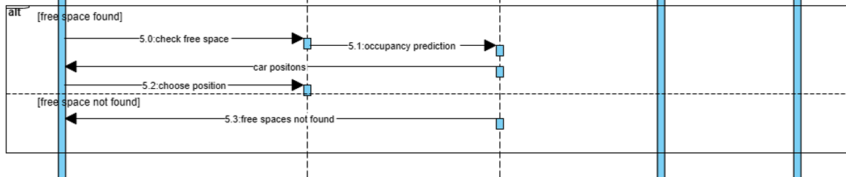

If we have free positions make the driver choose space if not have free space return free spaces not found

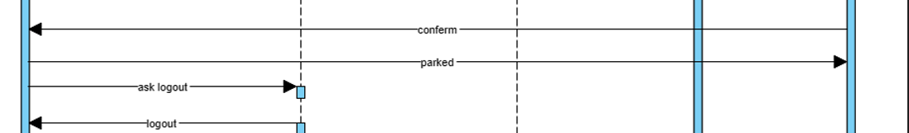

In the end, the driver parks his car.

References:

[1] Egypt's Central Agency for Public Mobilization and Statistics (CAPMAS)

[2] Jin Cao, Monica Menendez, and Rashid Waraich, “Impacts of the Urban Parking System on Cruising Traffic and Policy Development: the Case of Zurich Downtown Area, Switzerland,” Transportation, forthcoming.

[3] Pradhananga, Pujan, et al. "RFID Based Remote Monitoring Techniques for IoT Smart Parking System." The International Conference on Innovations in Computing Research. Springer, Cham, 2022.‏

[4] Park, Soothing. "D-PARK: User-Centric Smart Parking System over BLE-Beacon Based Internet of Things." Electronics 10.5 (2021): 541.‏

[5] Mahfooz Ul Haque, Hafiz, et al. "A context‐aware framework for modeling and verification of smart parking systems in urban cities." Concurrency and Computation: Practice and Experience 33.2 (2021): e5401.‏

[6] Gupta, Rekha, et al. "An IoT-based smart parking framework for smart cities." Data management, analytics and innovation. Springer, Singapore, 2021. 19-32.‏

[7] Charles, Joel, et al. "RFID Based Smart Parking System Using Firebase." International Journal of Research in Engineering, Science and Management 5.2 (2022): 31-33.‏

[8] Jhugroo, M. Saheer, M. Shahil Kataully, and Soulakshmee D. Nagowah. "Implementation of a Smart Parking System for a University Campus." Progress in Advanced Computing and Intelligent Engineering. Springer, Singapore, 2021. 707-718.

[9] garwal, Yash, et al. "IoT based smart parking system." 2021 5th International Conference on Intelligent Computing and Control Systems (ICICCS). IEEE, 2021.‏

[10] Atiqur, Rahman. "Radio frequency identification based smart parking system using internet of things." IAES International Journal of Robotics and Automation 10.1 (2021): 41.‏

[11] Peng, Guochao, et al. "Investigating the usage of IoT-based smart parking services in the borough of Westminster." Journal of Global Information Management (JGIM) 29.6 (2021): 1-19.‏

[12] Nasution, Alam Nasyrah Muharram, Rendy Munadi, and Sussi Sussi. "Design and Implementation of Smart Parking System Using Location-Based Service and Gamification Based on Internet of Things." JURNAL INFOTEL 13.2 (2021): 63-75.‏

[13] Babu, M. V. S. S., et al. "Smart Parking System Using IOT." Dogo Rangsang Research Journal 14.6 (2021).‏

[14] Cokro, Raden SB, et al. "Designing Smart Parking System through the Use of IoT and Big Data." International Journal of Advanced Trends in Computer Science and Engineering 10.5 (2021).‏

[15] Vivekanadam, B. "Smart Parking with Fair Selection and Imposing Higher Privacy Constraints in Parking Owner and Driver Information." IRO Journal on Sustainable Wireless Systems 3.1 (2021): 11-20.‏

[16] Anwar, Aamir, Nagham Saeed, and Parisa Saadati. "Smart Parking: Novel Framework of Secure Smart Parking Solution using 5G Technology." 2021 IEEE International Smart Cities Conference (ISC2). IEEE, 2021.‏

[17] Jameel, F., & Zafar, N. A. (2021, May). Formal Modeling and Automation of E-Payment Smart Parking System. In 2021 International Conference on Digital Futures and Transformative Technologies (ICoDT2) (pp. 1-6). IEEE

[18] Manjula, G., Govinda Rajulu, G., Anand, R., & Thirukrishna, J. T. (2022). Implementation of smart parking application using IoT and machine learning algorithms. In Computer Networks and Inventive Communication Technologies (pp. 247-257). Springer, Singapore.‏

[19] Sudhakar, M. Venkata, et al. "Development of smart parking management system." Materials Today: Proceedings (2021).‏

[20] Mondal, Md Ashifuddin, Zeenat Rehena, and Marijn Janssen. "Smart parking management system with dynamic pricing." Journal of Ambient Intelligence and Smart Environments Preprint (2021): 1-22.‏

[21] Alharbi, Awad, et al. "Web-based framework for smart parking system." International Journal of Information Technology 13.4 (2021): 1495-1502.‏

[22] Canli, Hikmet, and Sinan Toklu. "Deep learning-based mobile application design for smart parking." IEEE Access 9 (2021): 61171-61183.‏